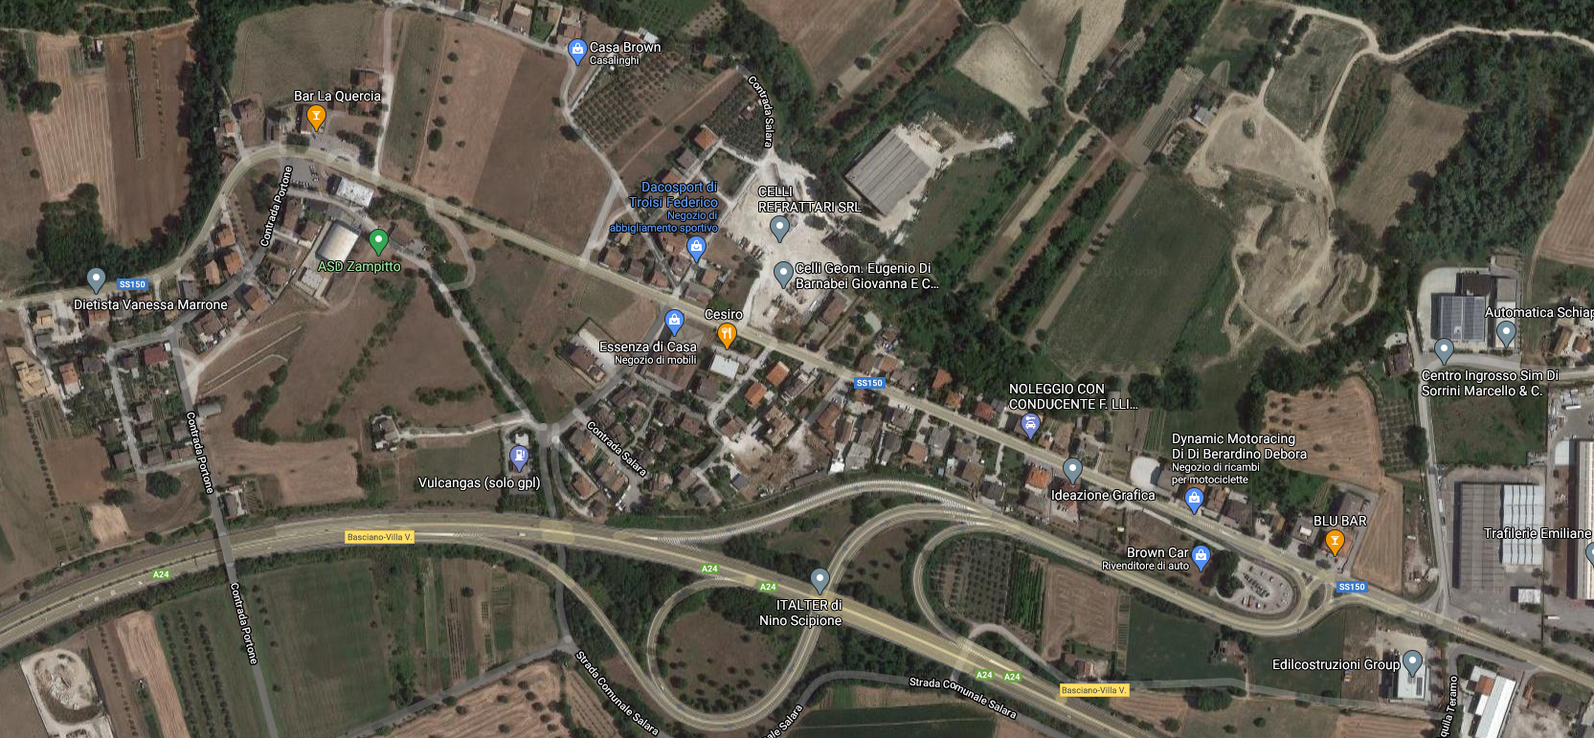
USCITA AUTOSTRADA
TENSOSTRUTTURA

PLUS CODE: JP7F+38 Basciano, Provincia di Teramo
LINK: https://www.google.com/maps/place/8FJMJP7F%2B38/@42.6126914,13.7211238,17z/data=!3m1!4b1!4m5!3m4!1s0x0:0x0!8m2!3d42.6126875!4d13.7233125

